|  |
| --- |
| Experiment No. 2 |
| Basic gates using universal gates. |
| Name: Harsh Tripathi |
| Roll Number: 59 |
| Date of Performance: |
| Date of Submission: |

**Aim -** To realize the gates using universal gates.

**Objective -**

1. To study the realization of basic gates using universal gates.
2. Understanding how to construct any combinational logic function using NAND or NOR gates only.

**Theory -**

AND, OR, NOT are called basic gates as their logical operation cannot be simplified further.

NAND and NOR are called universal gates as using only NAND or only NOR, any logic function can be implemented.

**Components required -**

1. IC’s 7400(NAND) 7402(NOR)

2. Bread Board.

3. Connecting wires.

**Circuit Diagram -**

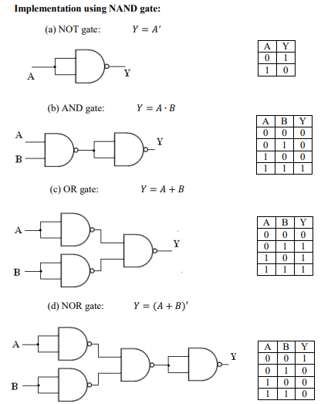

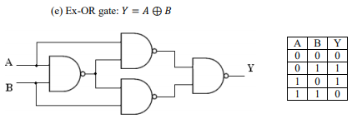

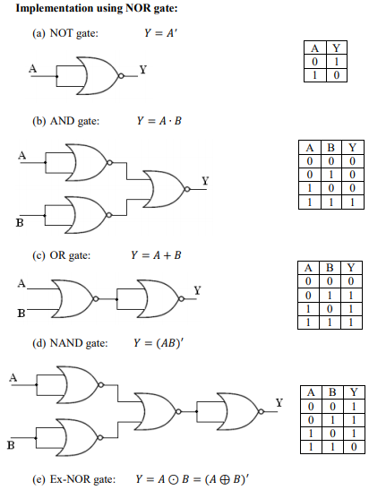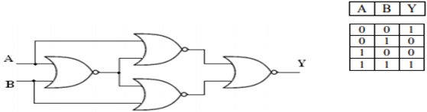

**Procedure:**

a) Connections are made as per the circuit diagrams.

b) By applying the inputs, the outputs are observed and the operations are verified with the help of truth table.

**Output:-**

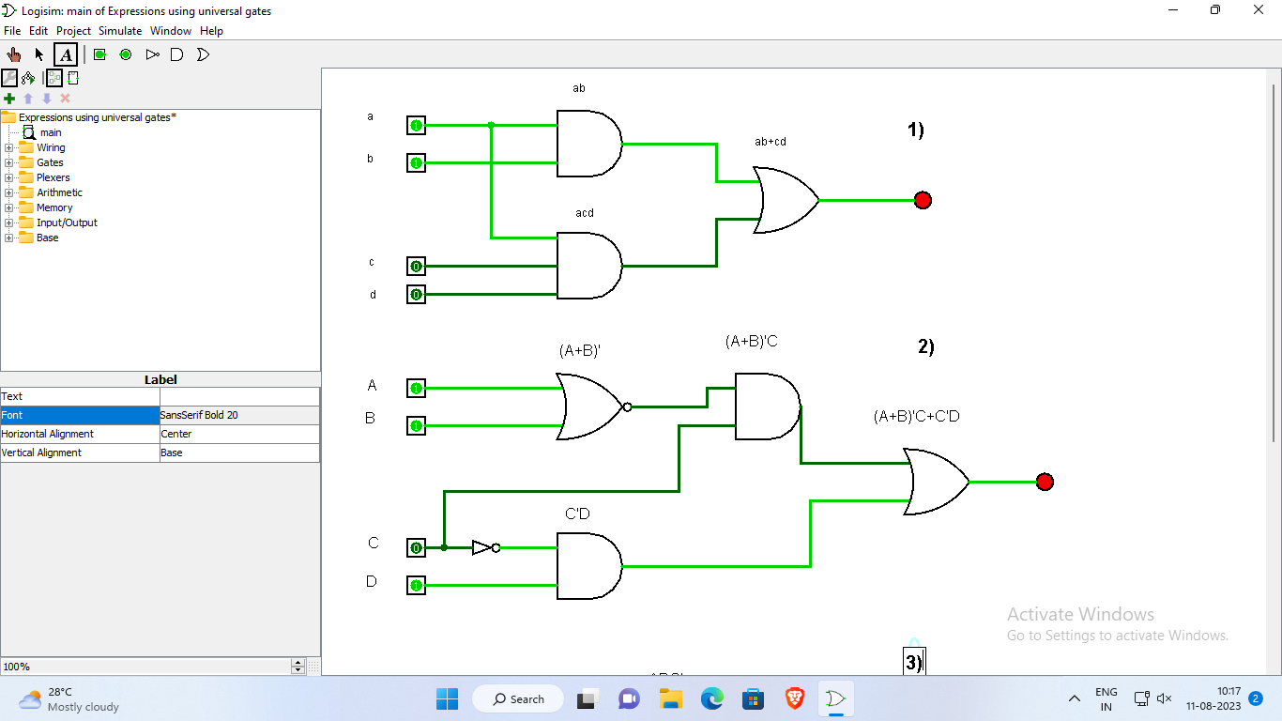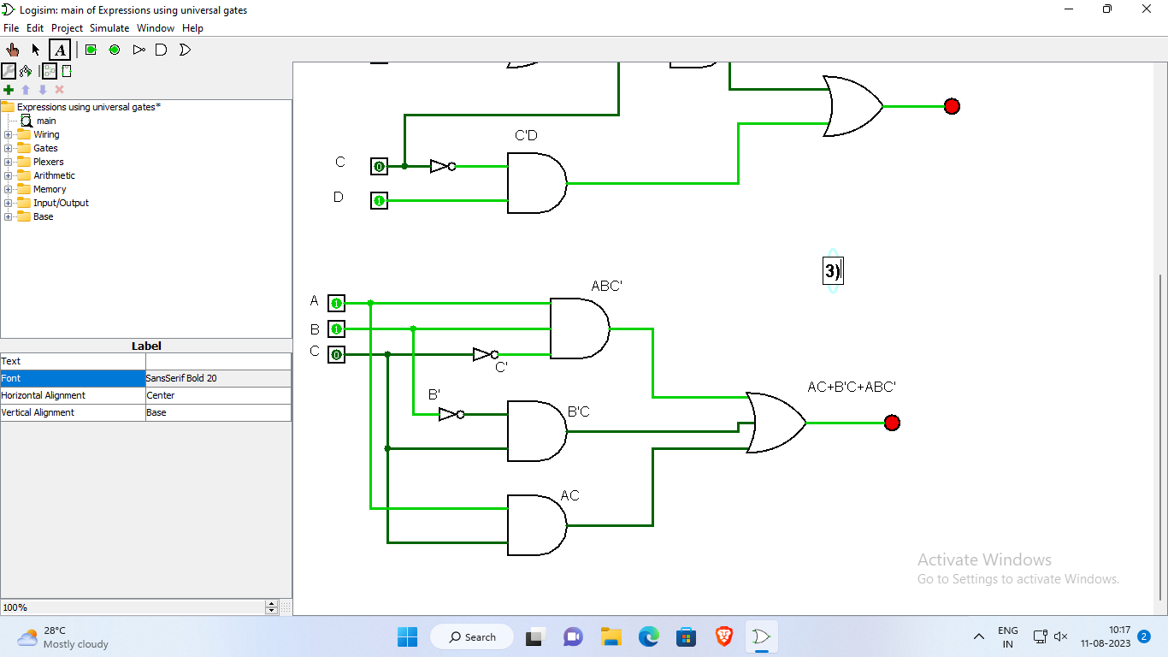

**Conclusion** –

When exploring the realm of digital circuit design, the concept of implementing basic logic gates through universal gates presents an intriguing and versatile approach. By leveraging the fundamental properties of universal gates such as NAND and NOR gates, it becomes evident that complex logical operations can be accomplished through the arrangement of these basic components. This not only showcases the remarkable adaptability and efficiency of these universal gates but also underscores the significance of their role in the broader landscape of digital logic design.